# 

Instructor’s Guide ReadMe

Blueprints by Marcos Romero

# About This Guide

This guide was developed as a companion to Marcos Romero’s Blueprints compendium website at http://romeroblueprints.blogspot.com/p/table-of-contents.html.

This guide was authored by Marcos Romero.

This guide has been technically edited for accuracy by Epic Games.

This guide was copyedited by Katie Haywood.

## License

This work is licensed under the Creative Commons Attribution-NonCommercial 4.0 International license.

To view a copy of this license, visit http://creativecommons.org/licenses/by-nc/4.0/ or send a letter to

Creative Commons, PO Box 1866, Mountain View, CA 94042, USA.

# Guide Contents

The guide contains 13 Lectures, 26 cooresponding excercises, 13 quizzes, 3 tests and a final.

Additionally, project files for Lecture 5 are provided.

## Exercises

Exercises are short, in-class or take-home tasks for your students to complete to help them gain hands-on practice with the tools. These are provided as editable Word files (.docx).

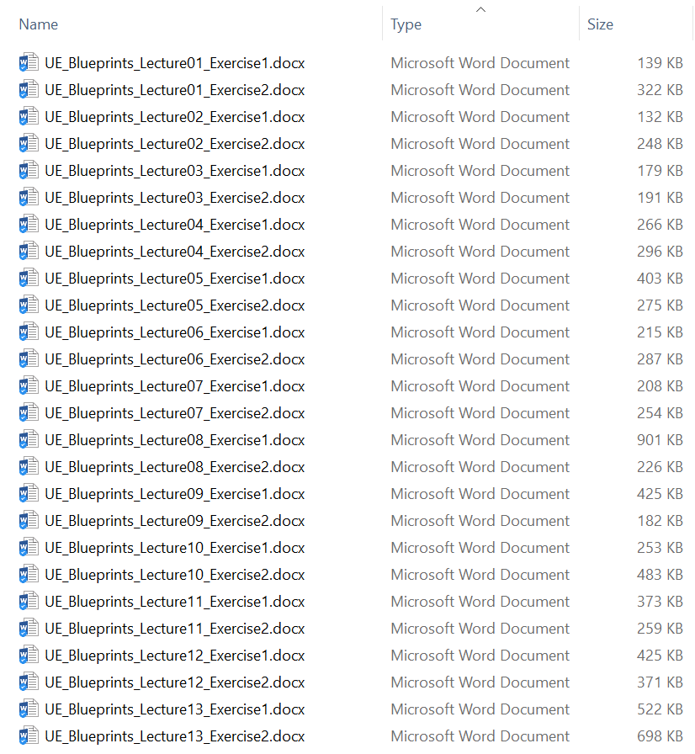

## Files

Source data files are provided as learning resources. These must be unzipped and stored on a local drive before using. The files may be in any file format, such as .fbx or .tga.

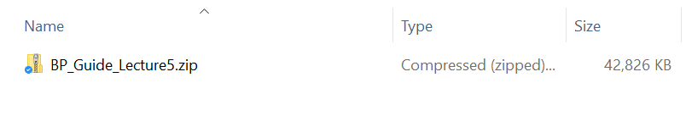

## Lectures

Lectures are pre-made presentations for each topic covered by the guide. These are provided as editable PowerPoint files (.pptx).

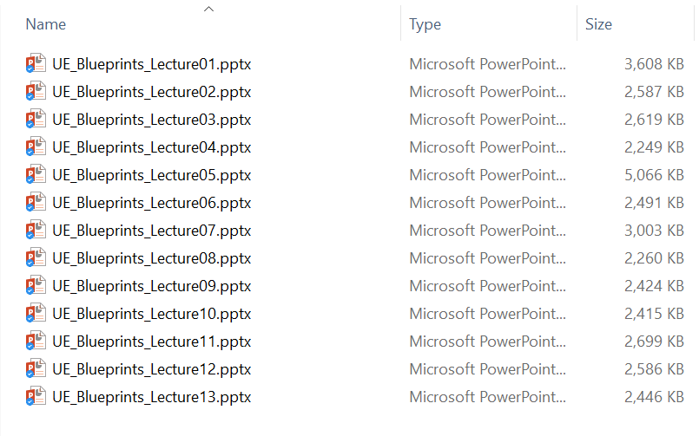

## Quizzes

Quizzes are simple assessments with answer sheets. These are provided as editable Word files (.docx).

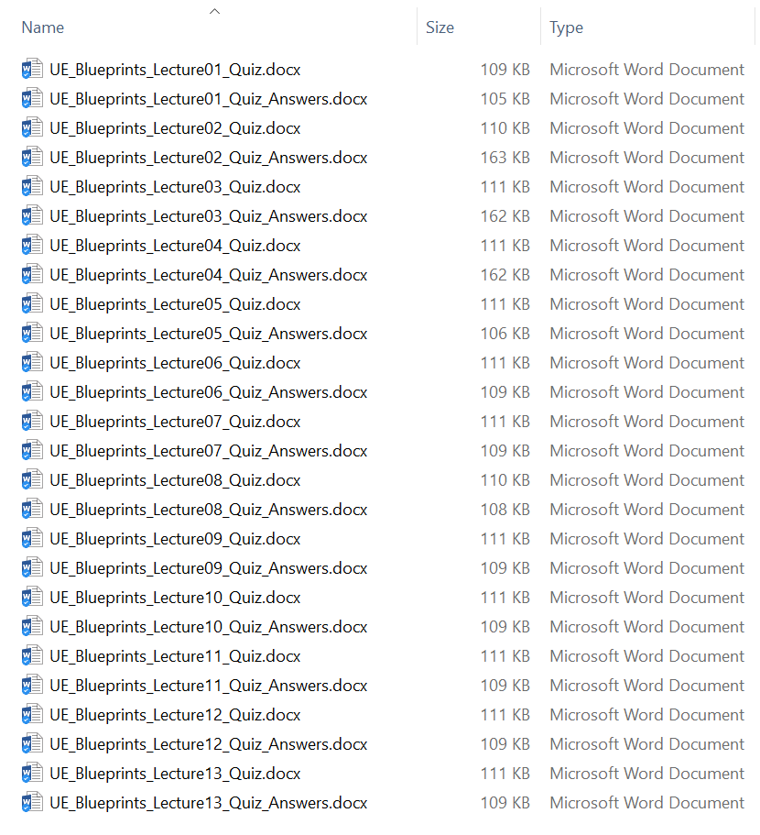

## Terminology

Detailed terminology sheets are intended to help both the instructor and students learn new concepts. These are provided as editable Word files (.docx).

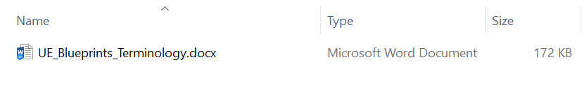

## Tests

Tests are detailed evaluations and answer sheets that cover large sections of the topic. These are provided as editable Word files (.docx).

